STUDENT DEPRESSION & LIFESTYLE DASHBOARD

Abstract
Mental health issues among students have become a critical concern in recent years due to academic pressure, lifestyle changes, excessive use of social media, and lack of proper sleep and physical activity. This project, titled “Student Depression & Lifestyle Dashboard”, aims to analyze student lifestyle patterns and their relationship with depression using data analytics and visualization techniques.
The project uses a structured dataset containing academic, lifestyle, and mental health indicators such as CGPA, sleep duration, physical activity, study hours, social media usage, stress level, gender, department, and depression status. A dynamic and interactive dashboard is developed to visually represent insights and Key Performance Indicators (KPIs). This dashboard helps in identifying trends, patterns, and risk factors associated with student depression, enabling institutions and stakeholders to make data-driven decisions for student well-being.
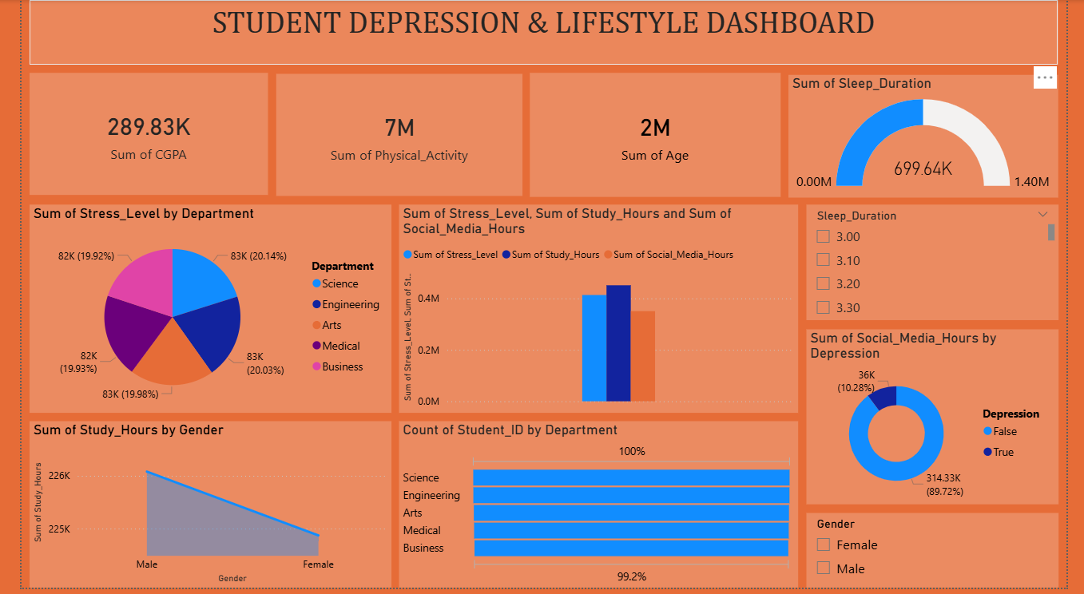

Problem Statement
Students today face increasing levels of stress due to academic workload, competitive environments, poor sleep habits, and excessive social media usage. These factors significantly contribute to mental health issues such as depression and anxiety. However, identifying these issues early is challenging due to the lack of consolidated and visualized data.
Objective:
To design an analytical dashboard that integrates academic, lifestyle, and mental health data to identify patterns related to student depression and lifestyle habits.

Objectives of the Project
- To analyze the relationship between lifestyle factors and student depression
- To visualize key academic and lifestyle metrics using an interactive dashboard
- To compare stress levels across departments
- To study the impact of sleep duration, study hours, and social media usage
- To provide insights that can support mental health awareness and interventions

Dataset Description
The dataset used in this project consists of student-level data collected from surveys and academic records. Each record represents an individual student.

Dataset Attributes
- Student_ID: Unique identifier for each student
- Age: Age of the student
- Gender: Male / Female
- Department: Science, Engineering, Arts, Medical, Business
- CGPA: Academic performance indicator
- Study_Hours: Average daily study hours
- Sleep_Duration: Average sleep duration (hours)
- Physical_Activity: Time spent on physical activities
- Social_Media_Hours: Daily social media usage
- Stress_Level: Measured stress score
- Depression: Mental health status (True / False)

Methodology
- Data Collection – Student lifestyle and academic data collected
- Data Cleaning – Removal of missing values and normalization
- Data Processing – Aggregation and calculation of sums and counts
- Data Visualization – Dashboard created using BI visualization tools
- Analysis – Interpretation of trends and relationships

Key Performance Indicators (KPIs)
The dashboard highlights the following KPIs:
- Total CGPA Sum: 289.83K
- Total Physical Activity: 7M
- Total Age: 2M
- Total Sleep Duration: 699.64K
- Total Students by Department
- Depression Count vs Non-Depression Count
These KPIs provide a high-level overview of student academic and lifestyle patterns.

Dashboard Analysis

Stress Level by Department
A pie chart represents stress distribution across departments:
- Science, Engineering, Arts, Medical, and Business show nearly equal stress contribution
- Engineering and Medical students show slightly higher stress levels

Stress Level, Study Hours & Social Media Usage
A clustered bar chart compares:
- Stress Level
- Study Hours
- Social Media Hours
Insight:
Higher social media usage and study hours are associated with increased stress levels.

Study Hours by Gender
- Male students show slightly higher total study hours compared to female students
- Indicates variation in academic engagement patterns

Student Count by Department
A horizontal bar chart shows balanced student distribution across all departments, ensuring unbiased analysis.

Social Media Usage by Depression Status
- Students with depression show significantly higher social media usage
- Non-depressed students have comparatively lower usage
This highlights social media overuse as a potential risk factor.

Sleep Duration Analysis
A gauge chart displays total sleep duration, indicating that many students do not achieve optimal sleep levels.

Tools & Technologies Used
- Data Source: CSV Dataset
- Data Analytics Tool: Power BI / Data Visualization Tool
- Visualization Types:
  - KPI Cards
  - Pie Charts
  - Bar Charts
  - Donut Charts
  - Gauge Charts

Advantages of the System
- Easy identification of mental health risk factors
- Visual and interactive data representation
- Helps educational institutions plan interventions
- Supports data-driven decision making

Limitations
- Dataset size may be limited
- Self-reported data may contain bias
- Depression is treated as a binary variable

Future Enhancements
- Integration of machine learning models for depression prediction
- Real-time data collection
- Sentiment analysis from student feedback
- Personalized mental health recommendations
- Mobile and web-based dashboard deployment

Conclusion
The Student Depression & Lifestyle Dashboard successfully demonstrates how data analytics and visualization can be used to understand student mental health patterns. By correlating lifestyle habits with depression indicators, the project provides meaningful insights that can help educational institutions improve student well-being. This project emphasizes the importance of data-driven mental health monitoring and serves as a foundation for advanced predictive and intervention-based systems.

References
- World Health Organization (WHO) – Student Mental Health Reports
- Data Visualization and Analytics Literature
- Academic Journals on Student Stress and Depression

